1. How is velocity related to acceleration? What are the three ways an object can accelerate?
Acceleration is the change in velocity which means that any time that speed or direction changes, the acceleration changes. The three ways an object can accelerate are 1) speed up 2) slow down or 3)change direction
2. Why is it better to wear a white T-shirt in the sun rather than a black T-shirt?
The white T-shirt will reflect all the colors of light and therefore keep the light from touching your skin. The black T-shirt will absorb all the colors of light and you will feel warmer.
3. Why is water (H₂0) a compound?
Because hydrogen and oxygen are chemically combined in a specific ratio. All compounds have a chemical formula while mixtures do not.
4. What does it mean when we say metal is a good conductor?
It means that metal allows heat AND electricity move through easily
5. Gravity is the force of attraction between 2 objects. What 2 factors can change the amount of gravity?
Mass and distance. The larger the mass, the more the gravity and the closer the two objects, the more the gravity.
6. What is convection?
Thermal energy transferred by moving molecules in a fluid due to a change in density. Hot rises, cold sinks in liquids and gases
7. In the chemical formula, CH₄, what does the 4 represent?
The number of hydrogen atoms
8. Look at the diagram, which is a pure substance? How do you know? Sample 3 because the molecules look the same
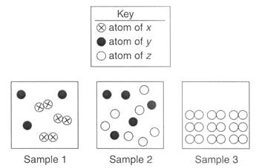
9. Can you change one element into another? Why or why not?
No, because elements cannot be broken down by chemical or physical means
10. What is the difference between mechanical and electromagnetic waves?
Mechanical | Electromagnetic
transfers energy | transfers energy
needs a medium/matter | does not need a medium/matter
cannot travel through empty space | can travel through empty space
consists of longitudinal and surface waves | consists of transverse waves

11. Simple machines are used to make work easier. How do they make work easier?
Simple machines change the way work is done. They DO NOT change the AMOUNT of work. Machines make work easier by changing the size of the force required or the distance over which the force is exerted.
12. In what direction does heat always flow?
Heat always flows from the warmer object to the cooler object until all objects reach the same temperature
13. If an alarm clock is placed in a sealed vacuum container (empty space) and goes off, what would you notice?
You would see the light but not hear the alarm because light is electromagnetic and can travel through empty space and sound is mechanical and cannot travel through empty space.
14. Explain Newton’s Third Law of Motion and give an example.
Newton’s third law says for every action there is an equal and opposite reaction. For example, if you are on a raft on a lake and you jump forward the raft will go backward.
15. Another scientist observes a change and is not sure whether it is chemical or physical. What could you tell them to look for to help them figure out if it is a chemical change?
Tell them to look for the signs of a chemical change:
1) fizzing or bubbling to show production of a gas 2) production of light 3) change in temperature 4) change in smell 5) change in color

16. Define the physical states:
solid has a definite shape and definite volume; particles vibrate in place.
liquids have no definite shape but a definite volume, particles slide past one another
gases have no definite shape or volume; particles are far apart and move rapidly

17. Draw a roller coaster and label where the most potential and kinetic energy would be.
PE

KE

18. Draw reflection Draw refraction Draw diffraction
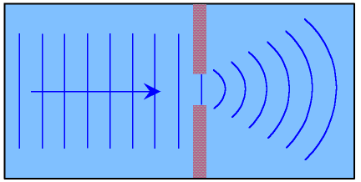

19. When you build an electromagnet; the electric current creates a ___magnetic___ field. Therefore, a magnetic_____ field can create an ______electric___________ current.
20. State the energy conversions in a car starting with the gasoline. What could make a car more efficient?
Chemical to thermal to mechanical (kinetic) and electrical; you could make it more efficient by making more kinetic and less thermal.
21. State the energy conversions in a light bulb that is plugged into the wall.
Electrical to light and heat
22. Compare and contrast series and parallel circuits.
Series | Parallel
Shares current-one path | no shared current-multiple pathways
Adding bulbs makes existing bulbs more dim | adding bulbs does not affect brightness
if one goes out, all go out | if one goes out, others stay lit

23. Draw an electromagnet. Is the battery or the nail the electromagnet? The nail
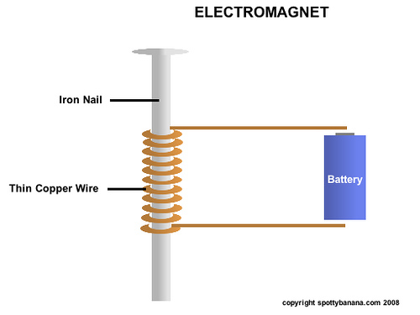
24. Describe how the following simple machines work:
  - Lever-board or rod that pivots on a fulcrum (pivot point)
  - Pulley-rope over grooved wheel
  - Wheel and axle-larger wheel that turns over a smaller circular object (axle)

25. A rock has a density of 3.0 g/ml. An ice cube has a density of 0.92 g/ml. If the density of water is 1.00 g/ml, describe what will happen to the rock and ice cube when they are placed in a cup of water.
The rock will sink because the density is greater than water and the ice will float because the density is less than water.

26. How does the speed of sound change in different mediums (such as solids, liquids, gases)?
Sound is fastest through 1) solids 2) liquids and then 3) gases

27. Compare and contrast an atom and a molecule.
Both are matter but atoms are smaller. Molecules are made of 2 or more atoms chemically combined. Molecules may be made of the same type of atom or different types of atoms.

28. How would you determine the density of an object with an irregular shape?
Find the mass using a balance and then find the volume using a graduated cylinder and the water displacement technique

29. Describe the location of metals, nonmetals, and metalloids on the periodic table.
Metals-most of the periodic table, left hand side
Metalloids-along the zig-zag line
Non-Metals-far right

31. Which characteristic of sound waves relates to loudness?
Amplitude

32. Explain why you need a closed system to prove the Law of Conservation of Mass.
Because for the only way the total amount of mass can remain the same is if nothing can get in or out

33. What is the difference between balanced and unbalanced forces?
Balanced forces do not cause a change of motion; the net force = 0 Newtons
Unbalanced forces do cause a change in motion; the net force is greater than zero Newtons

34. If the frequency of a wave increases, what happens to the wavelength?
If the frequency increases, the wavelength decreases

35. Define radiation.
Radiation is energy that travels through empty space in an electromagnetic wave. All energies on the electromagnetic spectrum are types of radiation

36. Draw a transverse wave with low amplitude AND high amplitude.

LOW AMPLITUDE HIGH AMPLITUDE
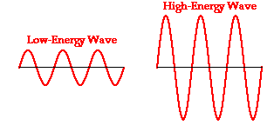
37. Describe what happens with frequency and pitch when you experience the Doppler Effect.
- Doppler Effect explains why a siren appears to have a higher pitch as it moves toward you. a) The Doppler Effect is the apparent change in the frequency of a sound caused by the motion of either the listener or the source of the sound.
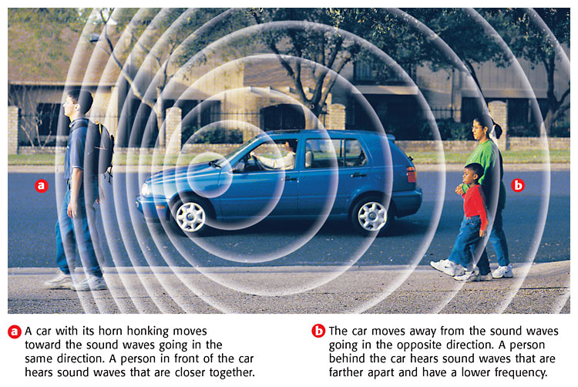
38. Draw and label the electromagnetic spectrum in the space below.
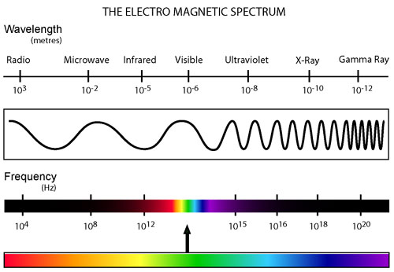

39. Name the location of the following particles of an atom.
Protons – nucleus
Neutrons – nucleus
Electrons –shells/orbits

40. Define conduction.
the transfer of thermal energy through direct contact

41. Some potassium oxide was placed in 9 grams of water and 112 grams of potassium hydroxide were made. What mass of potassium oxide was used?
potassium oxide + water potassium hydroxide
_103_ g + 9g 112 g

42. Give 3 examples of insulators.
rubber
wood
styrofoam

43. What is the difference between mass and weight?
mass | weight
constant | not constant (changes with gravity)
measured in grams | measured in Newtons
amount of matter in an object | measure of gravity

44. Use the figures below to answer the following questions.
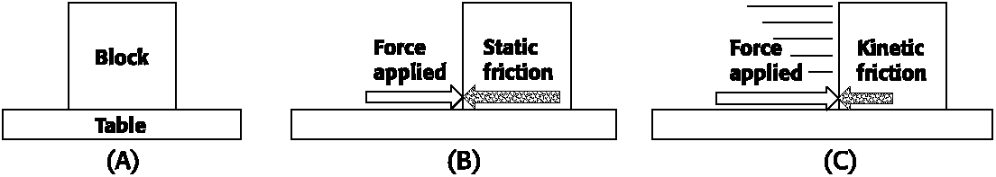

- Look at the Figure A above. Why does the block not move? no force applied

- Look at the Figure B above. What force keeps the block in place? friction because the frictional force is equal to the applied force

- Look at the Figure C above. The block is moving. What force acts against the movement of the block? friction but the block is moving because the applied force is greater than the frictional force

45. List the properties of metals.
solids at room temperature
shiny/luster
malleable
high conductivity
higher melting points

